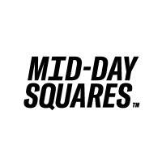

BMKT 405-01

Marketing Plan Proposal: Mid-Day Squares

Prepared By: Alysson Stamper, Julia Vinas, Hannah Evin, Brett Whitman, and Jessie Qin

Instructor: Danielle Wilson

Date: March 28th, 2022

### **Executive Summary**

**Overview:**

The Marketing Strategy and Tactical plan is designed to function as a blueprint to guide the snack brand Mid-Day squares. The marketing plan focuses on establishing a process that will be easy for Mid-Day squares to create and fully customize their marketing tactics and strategies in a more unified approach. Northwest consulting has put together this plan to participate and help develop the process.

**Marketing Plan Goal:**

This marketing plan aims to serve as a guide as to which marketing efforts are directed. It will be utilized to develop strategies and tactics for the marketing plan. It will also serve as questions about all the marketing strategies and tactics to ensure that they strategically align with the path toward the goal.

***Goal:*** *Have Mid-Day Squares use various strategies and tactics to increase sales revenues to $127 million by 2025.*

**Strategies and Tactics to Implement:**

The marketing strategy and tactical plan include certain different marketing strategies and tactics to ensure that numerous consumers are reached. Strategies such as utilizing promotional activities and building relationships with other companies are key areas that our team will discuss further in the plan.

Our team has also put together a tactical plan that highlights the use of word-of-mouth advertising, public relations, digital marketing, sales promotions, and social media and email marketing. These tactics will help Mid-Day squares reach their objectives of boosting their sales, reaching new consumers, selling existing or new products to current customers, developing service lines or new products, and utilizing marketing techniques to engage their target customers more effectively.

**Table Of Contents**

Executive Summary 1

Introduction 5

Mid-Day Squares Vision Statement: 6

Mid-day Squares’ Mission: 7

Situation Analysis: (PESTEL, SWOT, Porter’s 5 Forces) - See Appendices 7

SWOT Analysis: 7-13

PESTEL Analysis: 13-15

Porter's 5 Forces: 15-16

Marketing Objective: 17

Research-Primary Research Conducted and Findings: 17

Target Market Analysis 18

User Persona Profile: 20

Competitive Analysis: 20

Differentiation and Positioning: 23

Positioning Statement: 24

Unique Selling Propositions: 24

MDS Unique Selling Segment: 25

Marketing Strategies: 25-27

Tactical Plans: 27-31

Timeline: 32

Budget: 33

Measurement and Evaluation: 34

References: 35-40

Appendix A: PESTLE Analysis 41

Appendix B: Porter’s 5 Forces 42

Appendix C: SWOT Analysis 43

Appendix D: Target Market Analysis-Segmentation Variables 44-47

Appendix E: Competitive Analysis 48

### **Introduction**

The marketing strategy and tactical plan is to be presented to Mid-Day squares. The company specializes in making delicious protein-rich snacks in three different flavours. The bars are optimally filled with nutrition, plant-based, and organic.

Our team at Northwest Consulting has put together this marketing plan to help identify the target market, which we conducted through primary and secondary research. Our team has also put together the segmentation variables table on the target market, which can be seen in Appendix D. This plan will also discuss the overall situation analysis of Mid-Day squares. It will also go over specific tools used such as Porter's five forces, SWOT, and PESTEL analysis, which are in the appendices, to address the current situation further.

Northwest Consulting has also outlined a strategy to help increase Mid-Day squares sales revenue to $127 million by 2025. This document will also address certain tactics to help with this strategy. The plan will also highlight the primary research findings that our team has discovered. Our team has done this by conducting and distributing surveys through using sites such as LinkedIn, Facebook, Instagram, and Snapchat. Northwest consulting aimed to have a sample size of 60 respondents, and our team gathered results from 63 people.

The marketing strategy plan also goes over the Mid-Day squares target market and the research to determine the four significant segmentation variables. This paper also dives deep into the company's ideal consumer. Our team has created a user persona profile to help understand Mid-Day Squares ideal consumer. The paper also discusses the competitive analysis of Mid-Day squares. Where the brand is compared to its two main competitors Honey Mama's and Perfect Bar, in this section, our team will compare and emphasize this through four components, such as price, packaging, marketing, and brand valuation. Northwest Consulting has also created a competitive analysis table found in Appendix E.

Northwest Consulting will also outline the brand positioning and their differentiation from competitors to help gauge their position in the market more efficiently. This section will also state the company's positioning statement and the brand's unique selling proposition and segment. This marketing plan will also go over SMART goals and objectives to help understand the business's position. Northwest Consulting has also outlined potential marketing strategies and tactical plans to understand the marketing activities better to help achieve these goals.

This plan will go over the timelines of these deliverables and the budget that will need to be allocated to ensure what needs to done follows through. Our team has also put together measurements and evaluations to help understand the plan's effectiveness, and this will be measured through various key performance indicators.

**Mid-Day Squares Vision Statement**

*“Bottom line: we're The First FUNCTIONAL Chocolate Bar: Everything A Chocolate Bar Isn't, Everything A Protein Bar Wishes It Was.”*

### **Mid-Day Squares’ Mission**

Mid-Day Squares' mission is to produce multifunctional chocolate bars packed with nutrition that satisfy hunger and taste delicious. The bars are protein-rich snacks and are ‘top-notch’ compared to your average protein bar. The company does this by curating innovative ideas and technology to help create a food brand that aims to resonate with its consumer base.

**Situation Analysis: PESTEL, SWOT, Porter’s 5 Forces (See Appendices)**

The situational analysis for Mid-Day Squares revealed that the organization has an excellent foothold in the growing industry of plant-based and lifestyle foods. Through the SWOT analysis, PESTEL analysis, and Porter's five forces, an evaluation of the internal and external conditions that affect Mid-Day Squares are analyzed. The analysis revealed that MDS has various competencies that give them an advantage in a rapidly growing consumer-packaged goods industry. Another common theme is the topic of sustainability and its relationship with plant-based eating. Environmental concerns have led many consumers to reduce their meat intake or become vegetarians or vegans. The analysis also recognizes recent shifts in consumer behaviour that are altering the food industry. One thing is clear, plant-based products are here to stay and grow.

Additionally, as information on dietary habits come out, consumers are looking for healthier, more sustainable, and ethically sourced food products. The broader snack and foods industry is expansive and oversaturated, with prominent industry players having a vast market share. The high regulation of the food industry, and the additional costs they ensue, is also a notable factor as it reduces profits for companies. Similarly, as the economy recovers from the COVID-19 pandemic, inflation and tax rates are high, leading to less money in consumers' pockets.

**SWOT Analysis**

The SWOT analysis (Appendix C) seeks to understand the internal and external business environment MDS operates to reveal strategies to improve marketing efforts. Firstly, the analysis focuses on the internal strengths and weaknesses of the MDS brand. Next, the external opportunities and threats of the industry MDS is operating in will be touched upon.

***Strengths***

MDS has several core strengths that give them an advantage over competitors:

* ***Strong Marketing Approach:*** The founders of MDS are heavily involved in marketing efforts through their company podcast, website, Instagram, Tik-Tok, and other social channels. This allows further connection of the company brand and product with its consumers, thus creating returning customers.
* ***Social Media Presence:*** MDS has a significant Instagram following with 75.9k Instagram followers (March 24, 2022), the company's Tik-Tok account with 5.5k followers and gaining over 64.6k likes in just over a year (March 24, 2020). These platforms are emphasized as they are heavily used and have high engagement numbers. The company is currently benefiting from consistent and engaging content.
* ***Appealing Branding and Packaging*:** The MDS products packaging is simple yet well-designed in terms of representing the brand. The colours, text fonts, and overall design of the packaging help differentiate it from competitors. Additionally, the packaging communicates nutritional information and ingredients clearly and effectively. Each product also has a funny and memorable name, such as “Fudge Yah,” that contributes to brand recognizability.
* ***Sustainable Public Image*:** MDS offers organic, plant-based, dairy-free fudge squares that are fair trade certified. As knowledge is growing of the impact that the meat and dairy industry has on the environment, consumers are seeking brands such as MDS. The aspect of organic plant-based products gives the organization considerable strength in the 2022 market.
* ***Professional Website*:** The website is appealing and easy to maneuver for visitors. It also gives a good representation of the brands' values. Search traffic is mostly organic, with 16.4k of its monthly visitors coming organically and only about 450 visitors coming through paid search engine efforts.
* ***Price:*** In terms of the plant-based snack foods market, MDS benefits from its fair price point. This is a strength because few competitors offer products with the portion size and nutritional value at a comparable price. They offer a price of nearly half of one of its direct competitors, Honey Mama’s, at CAD $4.49 with a similar portion size.

***Weaknesses***

* Now, we look at the areas in which MDS competitors hold an advantage. The weaknesses of the MDS brand are as follows:
* ***Lack of Full Website Optimization:*** While the company has created an efficient website, it is not fully optimized which leads to low search engine visibility. The company currently has a 44.6% bounce rate (Alexa, 2022) which is average. Contributing to this is, not all website content is linked in the footer, product reviews are difficult to find, and lack of vision and mission statements on the company website. For example, the MDS “about us,” or “The Mid-Day Squares Story,” pages are not linked to the footer.
* ***Low Interactivity on Some Social Media Platforms:***MDS Twitter and Facebook platforms are far less utilized than other media channels. The lack of consistent posting leads to low interactivity on these platforms, meaning the company may be missing an opportunity to connect with its consumers. The MDS Twitter account has not been active since April of 2019 and has 247 followers, their Facebook page has only 16.1k followers.
* ***Refrigeration of Products:*** An advantage other companies have over MDS is that their products are non-perishable and do not require refrigeration. Perishable goods, such as MDS products, are subject to more stringent regulations and requirements than non-perishable consumable goods. Perishable goods have unique requirements including: “being stored and shipped within a narrow temperature range, requiring a completely sealed container, and needing speedy shipment because the food product can overripen or decay.” (Smart Warehousing, 2021) Thus, goods that must be refrigerated involve a more involved and costly process in terms of production and shipment. Furthermore, frozen, and refrigerated foods require additional costs in acquiring shelf-space. In small grocery chains freezer section space, “costs up to $9000” (Chelstad, 2018), in larger chains this cost is much higher. For example, “Apple & Eve spent around $150,000 to get into a limited amount of Safeway locations” (Chelstad, 2018).

***Opportunities***

There are several opportunities for the external industry in which MDS operates, they are as follows:

* ***Growth of The Snack Foods Market:***The Global snack foods market, which includes confectionery products, “is set to reach $732.6 billion by 2026 with a CAGR of 6.7%.” (Report Linker, 2021) Demand for snack products is increasing steadily as hectic schedules and busy lifestyles are driving consumers to supplement traditional meals with convenient and healthy snack options. Furthermore, “the Canadian snack food market earned a total revenue of USD 9.8 billion; a 1.3 billion dollar increase from the prior year.” (Statista, 2021) Canadian consumers are most likely to purchase snacks at the grocery store, followed by dollar and convenience stores. No added sugar and low salt/sodium are the most important health attribute claims when making purchase decisions.
* ***Growth of The Plant-based Foods Market:*** While traditional non-nutritional snacks see continued monetary success, the plant-based foods industry is set to hit double digits. Global market trends display that the preference for sustainable and healthier foods is happening on a global scale. The global plant-based foods industry is, “currently worth 44.2 billion USD as of 2022, it is expected to reach 77.8 billion USD by 2025, and even further growth is expected by 2030 when the market is expected to reach 162 billion USD.” (Statista, 2021) The CAGR for plant-based foods from 2020 to 2027 is estimated to be 11.9%, meaning this is a rapidly growing industry.
* ***Canadian Plant-based Foods Market*:** Looking more narrowly at the Canadian market, we see that consumers are continually looking for plant-based products to add to their dietary mix. Nielsen data shows that “the sales of plant-based foods in Canada grew by 16% for the year ending in 2019, becoming an industry worth 500 million CAD” (Ewing, 2020) The Government of Canada has recognized plant-based foods as an important and growing industry. The government has identified the plant protein industry as a “Supercluster Initiative” and invested 150 million CAD into further development. In a recent survey, 43% of Canadians stated that they would eat plant-based substitutes for meat (Statista, 2022). Females between the ages of 19 and 34 are the demographic most likely to view eating plant-based products as a positive choice (Statista, 2022)
* ***Flexitarian Diets:*** While the vegan demographic, currently making up 5%, is driving the plant-based foods market growth, it is the “flexitarian” demographic which will be key in the industry moving forward. Flexitarians are, “consumers who have lifestyles whereby people mainly eat plant-based foods and occasionally include animal products in their diet.” (Webber, 2021) These flexitarians now make up a third of the US market and will continue to be a ‘key demographic’ moving forward. With the ever-growing global population, natural resources are becoming increasingly scarce, leading consumers to reduce or eliminate meat consumption.
* ***Shift In Consumer Buying Habits Due To COVID-19:*** The COVID-19 pandemic spawned an enormous shift in consumer buying habits. Research conducted by ADM suggests six behavioural shifts during the pandemic (2020). These shifts are, “increasing gut health and immune function, plant-based foods becoming mainstream, a new perspective on weight-management and metabolic health, eating to improve mental health, and a shift in shopping values” (ADM, 2020). This shift in consumer behaviour is positive for organizations that create plant-based products.

***Threats***

The external threats of the wider industry in which MDS operates are as follows:

* ***CPG Industry Leaders Entering the Plant-based Market****:* The consumer-packaged goods industry is highly competitive with industry giants having large shares of the market. Companies such as Pepsi Co. and McCain Foods LTD. can offer distinct types of snack products under various “brand names.” These industry leaders can offer their products at cheaper rates and expand risk across their extensive product lines. This poses a threat to smaller organizations as many of these companies are entering the plant-based snacks space. For example, Pepsi has formed a strategic partnership with Beyond-Meat Co, “to make plant-based snacks and drinks” (Matthews, 2021)
* ***High Price of Plant-based Products:***Plant-based product production is pricier than their animal-derived counterparts. This is because, “meatless alternatives are made on a smaller scale, while animal agriculture subsidies ensure animal products remain affordable for consumers.” (Rosenburg, 2022) The higher costs involved in plant-based snack production pose the largest threat to the industry. This has led to big industry players, such as Impossible and Just Egg, rushing to reduce the prices of their producers.
* ***Rising Inflation:***As of February 2022, “prices rose 7.9% compared to the year prior, including an 8% increase in food prices.” (Tepper, 2022) This is the largest annualized growth in CPI inflation since the 1980s economic recession. As inflation for essential products increases, consumers have less money to spend than the year prior. This may cause consumers look for more low-cost options.

**PESTEL Analysis**

This analysis (Appendix A) is designed to understand the macro-environmental impact on Mid-Day Squares business and uncover growth opportunities. Focusing on the broader food industry seeks to understand how political, economic, sociological, technological, environmental, and legal factors affect MDS business.

Politically speaking, the food industry at large is restricted by governments' comprehensive regulatory frameworks. The regulatory nature of the food industry means a smaller margin of profits for organizations within the industry. The cleanliness in production, the standards for storing and transporting products, and requirements for labourers are costly to organizations that sell food products. Additionally, depending on the region, corporate tax rates fluctuate depending on the political party, resulting in fewer sales. On the other hand, the Canadian and American governments have been investing in the growth and development of the plant-based foods industry. For example, the Canadian Government gave a significant boost to the plant-based food industry, "In June of 2020, the government announced a 100-million-dollar investment." (Hanson, 2020)

Regarding the economy, North American inflation rates and supply chain issues pose a threat to MDS as it forces prices to rise. Additionally, increased labour costs throughout the US and Canada also lead to less profit as employees must be paid more. However, this increase in labour costs coincides with growing disposable incomes. Individuals in the lower, middle, and upper classes have more money to spend. In America for example, from 2000 to 2018 lower-class income rose from $28,200 to $28,700, the middle-class grew $81,700 to $86,600, and upper-class incomes went from $192,200 to $207,400” (Horowitz, Igielnik, Kochhar, 2020). This has enormous benefits for plant-based snacks as they are more costly than the traditional snacks market.

Sociologically, health consciousness and awareness of dietary restrictions have had an enormous impact on the foods industry. As more studies come out and people learn the benefits of healthy eating, people are more aware of what they put in their bodies. This has forced fast-food companies, such as McDonald's and Taco Bell, "to introduce products to entice the health-conscious consumer" (Das and Dharra, 2021). This indicates a shift away from high-calorie foods toward healthier alternatives. Consumers are also more aware that their dietary restrictions have led to more plant ingredients and restricting other ingredients such as gluten. Furthermore, consumers are receptive to brand equity and transparency.

In terms of technology, e-commerce platforms, advertisement technology, and automation are essential factors within the food industry. The growth of online platforms to purchase has increased organizations' sales mix. Online ad technology has improved leaps and bounds and changed the way products are marketed. Technology has changed marketing by "making campaigns that are more personalized and immersive for people and creating ecosystems that are more integrated and targeted for marketers." (Hannay, 2019) Automation, which is becoming more popular, poses a net positive effect for organizations in the industry as they will spend less on labour and reduce the likelihood of human error.

Environmentally, consumers are looking for more sustainable products as they are worried about the impact of meat. According to The Economist Intelligence Unit, "there has been a 71% increase for online searches for sustainable goods globally." (Martins, 2022) As knowledge grows about the impact of meat on water consumption and the growth of carbon footprint, consumers are adopting plant-based diets. Consumers are also moving towards more ethically sourced foods, choosing companies who share these values. This provides an excellent opportunity for plant-based products.

Legally, companies in the food industry have high standards for safety matters in how food should be transported, stored, and prepared. If any legal matters are breached, costly lawsuits may ensue. Strict trademark laws also pose a threat to companies operating within the industry.

**Porter's 5 Forces**

This model (Appendix B) identifies and analyzes five competitive forces that shape the food and plant-based food industry to MDS’s competitive environment. These five competitive forces are the threat of new entrants, bargaining power of suppliers, threat of substitute products, bargaining power of buyers, and competitive rivalry between firms.

The threat of new entrants is low in the industry as there are high barriers to entry. A large amount of capital is required to enter the industry and acquire shelf space. Complex distribution channels make it difficult for organizations to sell products. Governmental policies also keep the food industry tightly regulated.

The bargaining power of buyers is high as inflation is raising the cost of goods leading to more difficult purchase decisions. Cheaper traditional-based snack products pose a threat as plant-based products cost more on average. Tax regulations add another problem to the purchase decisions of consumers. Thus, higher taxes may result in fewer sales.

The threat of substitute products is high within the food industry. The vast availability of traditional snacks and their lower price provided by the industry giants pose a threat to the entire market. For example, “the Nestle group leads the consumer goods industry with a 44.7% regional share of North and South America.” (Wunsch, 2022) Under the Nestle umbrella are brands such as Kit-Kat, Nespresso, and Perrier, allowing them to offer a wide range of products across different markets. Given the amount of capital and brand recognition Nestle has at its disposal, it can offer more products at lower prices than smaller organizations.

The bargaining power of suppliers is high within the food and snack markets. Exclusive agreements between firms and suppliers and the inflated cost of raw materials give suppliers bargaining power. Other resources come from overseas making which means high shipping and transportation costs.

Lastly, the competitive rivalry between firms is due to the enormous number of products within the food and snack industry. Industry giants, such as Hershey’s, hold a significant market share, “with 32% of confectionery market share in the United States in 2020” (Statista, 2020), pose a threat to small and medium-sized enterprises. Many companies are operating in the plant-based market as it is one of the fastest-growing in North America.

### **Marketing Objective**

To increase Mid-Day Squares’ sales revenue within the plant-based snack space to $127 million by 2025.

**Note:** *The current plant-based snack market has a total value of $31.8 billion (Wills, 2020). If Mid-Day Squares were to achieve a market share of 0.40% within the next three years, it would equate to approximately $127 million in revenue.*

### **Research-Primary Research Conducted and Findings**

To gather further information about Mid-Day Squares, primary research was conducted through a recurring client interview in which one of the co-founders shared key information regarding the company’s performance and tactics. Survey questions were then curated based on the informational interviews and were sent out by the team on their respective social media profiles such as Facebook, Snapchat, Instagram, and LinkedIn. Given, the following data was gathered from a sample size of 63 respondents:

* **Survey Results (63 Respondents)**
  + 38 female (60.3%) and 25 male (39.7%) respondents.
  + 45 (71.4%) of respondents between ages 18-24, 14 (22.2%) of respondents are between the ages of 25-44, 3 (4.8%) of respondents are between the ages of 45-55, 1 (1.6%) respondent over the age of 55.
  + 61.3% of respondents claim they typically purchase protein/snack products at the grocery or convenience store.
  + 71.4% of respondents are unaware of the brand Mid-Day Squares.
  + Price (40 responses), taste/flavour (55 responses), and nutritional value (47 responses) are leading attributes of snack products for respondents.
  + 11 of the 18 respondents (61%) who have heard of the brand claimed they are “very likely” to suggest the brand to a friend/family member.

With the data presented, a conclusion of the lack of brand awareness present on the west coast can be deduced. However, it is still recommended by 61% of respondents as a ‘good’ product. Therefore, they have a good brand reputation. It further aligns with the unique selling proposition of Mid-Day Squares’ products. The client may benefit from referring to the primary research results as it provides some understanding of the company’s status/position within its Western Canada market. They must focus on boosting retail sales, doing more promotions, and building brand awareness. Also, Mid-Day Squares should be committed to providing a fair price, tasty flavours, and high nutrition value products.

### **Target Market Analysis**

Northwest consulting conducted research to determine the four major segmentation variables which would identify the ideal consumer for Mid-Day Squares: geographics, demographics, psychographics, and behaviours. From the research, we were able to get detailed information on the target consumer trends, such as veganism and vegetarianism trends on the rise in both Canada and the United States. Refer to Appendix D for in-depth information on each segment which guided the identification of the target market. According to Statistics Canada, 2.3 million Canadians living in urban areas are identified as vegan (Statistics Canada, 2021), while in the United States, 1.6 million residents are identified as vegan (Gallup, 2021). Our research also revealed that over 60% of the target consumers have a bachelor’s degree or higher (Statista, 2021). With all our research, we have produced an ideal target customer; the ideal customer is between the ages of 25-40 living in the city, working a busy job.

The job requires a minimum of a bachelor’s degree, such as a nurse, human resource manager, or accountant. They are busy, on the go from work to day-to-day life, and sometimes do not have the chance to sit down for a proper meal. These individuals often work in an office, and as we had mentioned earlier in this report, millennials expect their workplace to provide meals and or snacks. In line with our marketing strategy, this individual fits into Mid-Day Squares’ marketing objective as they are in the office, living a busy lifestyle and often stay at their desk to eat. This individual is health-conscious and rationalizes purchase. Money and time are stressors of these customers, and therefore they are sometimes brand loyal; they tend to pick the cheaper and quicker option. The “on-the-go” lifestyle ties into their “wellness-oriented” lifestyle, leading them to commonly be found out at the gym, at work or purchasing from health food stores.

Below is a user persona profile that gives a visual snapshot of what the target consumer looks like, their behaviours, and motives.

**User Persona Profile**

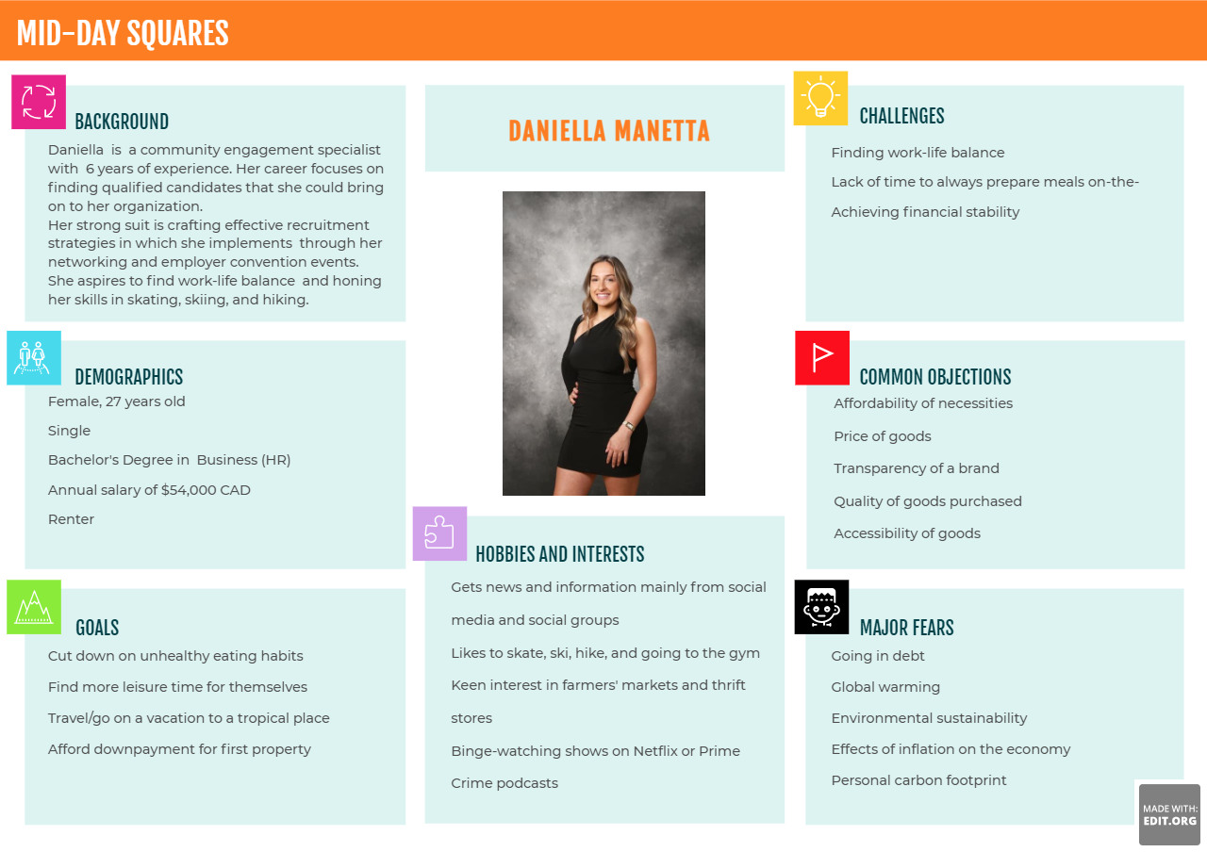

### **Competitive Analysis**

For a company like Mid-Day Squares to continue thriving within its industry, a competitive analysis amongst its main competitors was conducted to understand its position in the market further. (See Appendix D) Given this, Mid-Day Squares is benchmarked against *Honey Mamas* and *Perfect Bar.* The data collected emphasizes four main components:

1. **Price:**

Mid-Day Squares’ prices are similar in price compared to their two main competitors, Honey Mama’s, and Perfect Bar. A singular pack of Mid-Day Squares contains two bars at an average of 67g, priced at CAD 4.49 (Whole Foods, 2022). Honey Mama’s charges CAD 9.99 for their singular pack at around 70g (Nature Sante, 2022). An individual Perfect Bar of 65g average comes for CAD 3.19 (Whole Foods, 2022).

The Perfect Bar presents to be at a lower price. However, Mid-Day Squares factors in their ‘hunger-killer’ feature that both competitors lack focus on. Furthermore, Mid-Day Squares pushes its “bang-for-your-buck” initiative as it contains less fat, a minimum of at least three superfoods more than its counterparts, and about twice as less sugar.

1. **Packaging Appeal:**

Considering the packaging of Mid-Day Squares, it is much more distinct and recognizable to that of Honey Mama’s and Perfect Bar. For the three SKUs of Mid-Day Squares – ‘Peanut Butta’ (orange), ‘Fudge Yah’ (light brown), and ‘Almond Crunch’ (red), each has its colours that indicate their flavour. Hence, customers can make out the brand in a shorter amount of time.

Honey Mama’s carries the most SKUs out of the three brands. With thirteen flavours, assigning a specific colour to each SKU becomes difficult. Further analysis of their packaging concluded that the brand is heavily focused on warm-toned colours, limiting the opportunity for flavour distinction. For customers, this may be overwhelming and confusing given that certain flavours look remarkably like each other.

Like Honey Mama’s, Perfect Bar carries more SKUs than Mid-Day Squares. With twelve flavours, three are of a peanut butter variety. The company’s colours lean towards the pastel-earthy tones of brown, green, blue, and red. However, flavours such as ‘Almond Butter’ and ‘Coconut Peanut Butter’ do not correspond to their respective packaging colours (Perfect Snacks, 2022).

1. **Marketing Strategy:**

Mid-Day Squares’ marketing strategy takes a more organic and personal approach. The brand engages with its followers on social media through storytelling, fan Q & A’s, email marketing, and the curation of music videos. Its founders are heavily involved throughout these processes as they want to keep the personal aspect at the forefront. Mid-Day Squares also uses paid advertisement for platforms such as Facebook, Instagram, and Google search. Influencers and customers posting content about the brand come into play as well.

The differentiating component of their advertising tactics stems from engagement, clicks, and conversion being organic to that of algorithm manipulation. Honey Mama’s and Perfect Bar use a more traditional approach of influencer marketing, emailing lists, and emphasizing one strong feature of their product. Without a sense of personal touch, customers will find it more challenging to connect with a brand.

1. **Brand Valuation:**

The brand valuation of Mid-Day Squares is predominantly based on their current revenue of $11 million (Saltarelli, 2021). While being the lowest out of the three, it is tracing to a trajectory of $100 million within the next three years (Latif, 2021). In hindsight, hitting the hundred-million-dollar sales mark would surpass Perfect Bar’s valuation of $70 million (Hirsch, 2019). In an interview with Taste Radio, co-founders Jake Karls and Nick Saltarelli see to it that “the keys to its unique and compelling social strategy and why a commitment to clean ingredients and consistent communication with the brand’s consumers gave the brand a solid foundation on which to build” (Latif, 2021).

### **Differentiation and Positioning**

Mid-Day Squares differentiates itself from competitors through many different attributes. The company positions their products by using a characteristic-based positioning strategy. The company does this by creating appealing products to allow consumers to choose their products based on their characteristics and brand image (“Send Pulse,” 2022).

Mid-Day squares offer quality taste, texture, ingredients, and packaging. Mid-day Squares provides value to consumers by offering plant-based and organic snacks that fulfill one chocolate craving while satisfying hunger. The products are unique because they are tasty and made with wholesome and natural ingredients. Many protein bars do not have much value in offering a quality taste, ingredients, or nutritional value. (“Mid-Day Squares, 2022”)

For example, specific competitors, such as Perfect Snacks, make protein bars significantly higher in sugar than Mid-Day Squares. The perfect bar has around 18g of sugar per bar, whereas Mid-Day squares have 5g of sugar per bar. Not only does Perfect bar have much more sugar per bar, but the texture also is not as satisfying as Mid-Day squares. The perfect bar has a pastier texture, which is not as satisfying to chew, compared to Mid-day Squares which has a great texture that is soft and chewy and not chalky. This allows Mid-Day squares to have more opportunities to differentiate themselves from average protein bars or chocolate. For example, the brand can discuss the benefits of their bars in promotional strategies. (Powell,2021)

The company also differentiates itself through posting engaging and funny content. Mid-day squares have often done this by storytelling on Instagram by posting a day in the life in the office or posting funny photoshoots. The company also recently came out with an entertaining diss track on chocolate brand Hershey’s, as legal disputes have been ongoing in the past year. The content that Mid-Day posts on Instagram help them differentiate themselves and drive up the number of real followers. Doing so makes the brand stand out from competitors such as Honey Mama’s or Perfect bar.

Competitors such as Honey Mama’s or perfect bar are not as engaging through their content, as they do not offer as much storytelling as Mid-Day Squares. Also, Mid-Day Squares does not rely on traditional marketing, as do their competitors, but focuses on word-of-mouth advertising and other organically driven methods. Having the brand be so personalized also builds genuine relationships with their consumers. This also allows for a good differentiation strategy that improves the overall consumer experience with the brand. (“Mid-Day Squares Instagram:” n.d.)

### **Positioning Statement**

For health-conscious consumers who want to have a treat, Mid-Day Squares is a functional chocolate bar that suppresses hunger and provides nutrition, unlike Honey Mama’s, which are nourishing and have a variety of flavours.

*(NOURISH ~ DELIGHT Honey Mama’s makes an unprocessed, raw honey-sweetened chocolate treat that inspires joy and wellbeing)*

### **Unique Selling Propositions**

Mid-Day Squares exhibit unique benefits and stand out from their competitors through product attributes and marketing strategies. Three unique selling strategies are listed below, and please refer to Appendix D for an in-depth competitive analysis that details the unique selling propositions shown by Mid-Day Squares against direct competitors.

### **MDS Unique Selling Segment**

* **Price!** Compared to competitors that we looked at in the analysis, MDS has the lowest price… they are priced comparable to other “indirect competitors'' such as coffee which would be considered competition because they also function as a ‘mid-day pick-me-up”
* **Ingredients!** MDS ingredient list is short, and all the ingredients are natural and easy to pronounce (nothing artificial added into them)
* **Organic Email List and Following!** MDS email list is entirely organic and consists of people who have willingly signed up and are fans of the brand.

### **Marketing Strategies**

MDS currently uses a storytelling strategy on social media by using a personalized approach with its marketing strategies as founders are heavily involved. In non-traditional marketing, the company is organically driven. After analyzing all the research on situational analysis, target market analysis, and competitive analysis, we decided that MDS can use the promotion strategy to increase sales revenues to $127 million by 2025.

MDS’s strategy is to produce plant-based ‘hunger-killers’ featuring chocolate bars with high nutrients but low prices that our competitors cannot match. It is the best choice for those busy people between the ages of 25-40 living in the city who do not have enough time to prepare proper meals during work time but want to live a healthy lifestyle. The goal is to create awareness of “wellness-oriented” lifestyles and promote the products with its most outstanding feature – natural ingredients without any artificial added-in. Also, MDS keeps building and maintaining long-term relationships with their audiences to increase customer loyalty.

With the goal for Mid-Day Squares to hit a sales revenue of $127 million by 2025, a viable strategy for them is to expand their B2B initiatives. It will specifically fall into the route of Mid-Day Squares being one of the snack options available at a company’s office snack bar or cafeteria. Embarking on the opportunity would involve MDS building its clientele relationship with different companies and propping themselves as a snack supplier. Thus, curating a strategic plan to enter the corporate space is paramount in proceeding with the process.

Grocery-delivery service, Peapod, conducted a survey involving over a thousand full-time business professionals regarding free food provided in the office (Malcom, 2015). Results showed that employees’ happiness levels increase from 56% to 67% when given free food, a significant difference (Malcolm, 2015). At MDS’ current trajectory, they can prop companies to similar or better levels while benefiting from it from a financial and marketing standpoint.

To further support the corporate office B2B strategy, a key area to pay attention to are job seekers. Millennials are those that “love to try new things and they get bored very easily…” (Watson, 2016). To that point, MDS’ different flavours are at an advantage as it can be rotated on a weekly or monthly basis, or even a restocking schedule chosen by the client. As a younger generation involved in the workforce or seeking to be a part of it, a benefit they expect from companies is free snacks. Statistically, over 25% of these individuals imply that the benefit should just be a given (Watson, 2016). With that in mind, MDS can capitalize from the foreplay of understanding its target market of business professionals.

Work setting is another crucial indicator for deciding to enter the corporate office space. In a typical office environment, employees now spend an average of ten to fifteen hours sitting at their desks (Roberts, 2019). With increasing workload and stress levels, these individuals will result in the minimum optimization of their lunchtime. If a company’s office is situated within a central business district, chances are that nearby food places will have long lines during peak hours. Hence, Mid-Day Squares’ presence in office snack bars or cafeterias provides a solution to the dilemma.

Conclusively, the corporate office B2B strategy for Mid-Day Squares is a strongly suitable approach in achieving their sales revenue target. Contractual agreements with different companies may encompass wholesale deals, beneficial client relationships, and brand awareness and recognition. Employees exposed to the brand may encourage to purchase a pack of Mid-Day Squares for themselves at home or as a gift, further contributing to the increase in sales.

### **Tactical Plans**

MDS's objective is to boost sales; the company must find new customers, sell more products to existing customers, offer sales promotions, develop new products or service lines by using different marketing tactics to engage target customers. Key promotion types that are feasible include word-of-mouth marketing, sales promotion, digital marketing, public relations, social media marketing, and email marketing.

**Word-of-Mouth Marketing**

Word-of-mouth marketing provides quality service, products, or experience, and customers voluntarily will let others recommend the company's products or services. The formation of good word-of-mouth could build higher credibility. Word-of-mouth marketing helps companies increase sales, reduce costs of acquiring new customers, relationship costs, or maintenance costs. Thus, the company's profits will rise.

* Referral program
* Customer reviews
* Influencer marketing

**Sales Promotion:** Increase retail sales

Companies can use a variety of promotions to attract new consumers to try their products, or they can use promotions to repay the company's loyal customers. Over-intensive promotions can damage the brand image, while prolonged under-promotion can cause the company to lose a large market. A reasonable budget allocation for advertising and promotion can build a good brand image while expanding the market.

* Expand a new product line
* Promo codes
* Coupons

**Digital marketing (SEO):** Improve website design and search engine optimization to boost the bounce rate up to 55%.

Search engine development is to naturally improve the ranking results of a website in search engines to attract more potential customers to browse the website, increase the number of visits to the website, improve the company's sales performance, and gain benefits.

* **Web Design**
  + Implement calls-to-action
  + Attractive pages
  + Streamline content
  + Navigate hierarchy
  + Responsive design
* **Organic Optimization**
  + Site architecture improvements
  + ​​On-page optimization (Titles, Descriptions, URLs, Breadcrumbs, Content)
  + Local optimization
  + Link building

**Public Relations:** Further develop the customer base in British Columbia and improve brand recognizability. The alignment of business aims with essential components of public interest, as well as the creation of initiatives aimed at gaining public awareness and approval.

* Newspaper/magazine articles, seminars, speeches
* Offer excellent customer service
* Look for partnerships with other businesses
* Provide unique value - exceed the customer’s expectations

**Social Media Marketing:** Increase consumer engagement through social media, company podcasts, and LinkedIn profile.

B2B buyers increasingly use these channels to research potential vendors before making a purchase decision. The advantage of social media over traditional media is that it allows companies to get their brands in front of people faster and more efficiently. Social media has a higher lead closing rate than any other form of marketing. As visibility on social platforms grows, companies will have more opportunities to convert leads into actual customers. Customer satisfaction and brand loyalty contribute to a company's authority, but it all boils down to communication. When customers see a company posting on social media, especially when they see they respond to customers and post original content, customers will perceive the business as more credible.

* **Targeted Ads on Facebook, Instagram, YouTube, and Google**
* **Company Podcast**
  + Ask people to subscribe
  + Invite guests and star as a guest
  + Promote the podcast on social media
* **LinkedIn Profile**
  + Keep refining the company’s profile
  + Optimize the page for search
  + Create LinkedIn ad campaign
  + Highlight the best content
  + Regularly updated blogs
* **Grow the Brand’s Online Presence Through the Rapidly Growing Platforms of Instagram Reels and TikTok**
  + Instagram storytelling and Q&A fan-interaction activities
  + Use hashtags
  + Use visual effects
  + Leverage TikTok trends
  + Post on TikTok at the right time
  + Reach out to the right influencers

**Email Marketing**

Email marketing can recommend different content for different users. For each recipient of an email, tracking is possible, including the user opens and clicks, and detailed reports can be made for the next decision-making step. One of the key benefits of email marketing is that it can help companies sell their products. It is essential to use all customer data and information from targeted messaging to drive high email conversions.

* **Double Mid-Day Squares Email List From 50,000 People to 100,000 People** 
  + ​​Gamification (wheel of fortune)
  + Coupons - on the home page of MDS, there is a $5 off coupon that can be sent to you when the customers give emails to them
  + Utilize loyalty and referral programs
  + Include opt-in fields at checkout (get email offers and promos)

### **Timeline**

|  |  |
| --- | --- |
| **Date** | Deliverable |
| **Feb 9** | Survey completed - Quantitative |
| **March 1** | Survey responses collected and analyzed - Qualitative |
| **Feb 31** | All Secondary Research/Competitive Analysis Completed |
| **March 7** | Details of Marketing Plan |
| **March 9** | Marketing Strategy and Tactical Plan (DRAFT) |
| **March 16** | Marketing Strategy and Tactical Plan (FINAL) |
| **March 31** | Presentation |
| **TBA** | Presentation to client |

### 

### **Budget**

* ***How Much Revenue Do We Need?*** 
  + Most companies spend about 5% to 15% of annual revenue on marketing
  + Revenue: $10 million
  + Marketing expenses (annually): $10,000,000*5%=$500,000; $500,000/12=$41,666.67 for monthly
* How much sales do we need to make the target revenue?
* Return On Investment (ROI in terms of money spent on ads)
* Paid advertising (social media, product placement, distributor channels)
* SEO & content marketing
* Social media (organic & paid)
* Email marketing (20%)
* Branding
* Sales campaign (5%-25%)
* Customer service support
* Website design and management

|  |  |  |
| --- | --- | --- |
| **Budget Category** | **Tasks/Goals** | **Budget (monthly)** |
| Paid advertising | Increase sales  (Latif,2022) | $2,500-$3,000  (Kendig, 2019) |
| SEO & Content marketing | Boost the bounce rate to 55%  (Latif,2022) | SEO: $150-$2,000  Content: $250-$1,000  (Kendig, 2019) |
| Social media marketing (organic & paid) | Increase consumer engagement  (Latif,2022) | $2,500-$4,000  (Kendig, 2019) |
| Email marketing | Double Mid-Day’s email list from 50,000 people to 100, 000 people | $100-$1,000  (Kendig, 2019) |
| Branding (logos and illustrations) | Increase brand awareness  (Latif,2022) | $500-$1,000  (Kendig, 2019) |
| Customer service support | Develop the customer base | $1,000+  (Kendig, 2019) |
| Website design and maintenance | Improve website design | $3,000  (Kendig, 2019) |
| Hire professional employees/Sales campaign | Increase retail sales from 55% to 70% | $10,000+  (Kendig, 2019) |
|  |  | Total budget: $20,000-$26,000+ |

### 

### **Measurement and Evaluation**

The strategic plans and actions implied for Mid-Day Squares are to be measured on its effectiveness by the following key performance indicators (KPIs):

* Organic email list numbers - double it from 50k to 100k individuals
* Impressions/Ad clicks on different social media platforms (click-through rate) – Instagram is the most viable
* Conversion rate (prospective buyers to actual buyers) - online ads on Facebook, Instagram feed, Tik Tok clips, Twitter feed, and Google search engine
* Engagement & satisfaction levels
* Customer acquisition cost
* Sales (online sales and retail sales)

### **References**

Bar 70g honey mama tahini tangerine. Nature Sante. (n.d.). Retrieved March 9, 2022, from [https://www.naturesante.ca/products/85483500426?variant=41780803403927¤cy=CAD&utm_medium=product_sync&utm_source=google&utm_content=sag_organic&utm_campaign=sag_organic](https://www.naturesante.ca/products/85483500426?variant=41780803403927%C2%A4cy=CAD&utm_medium=product_sync&utm_source=google&utm_content=sag_organic&utm_campaign=sag_organic)

Bush, T. (2019, July 9). Pestle analysis of the food industry. PESTLE Analysis. Retrieved March 9, 2022, from <https://pestleanalysis.com/pestle-analysis-of-the-food-industry/>

Chelstad, E. (2022). Redirecting. Retrieved 26 March 2022, from [https://www.google.com/url?q=https://www.observanow.com/know-slotting-fees/&sa=D&source=docs&ust=1648329078464077&usg=AOvVaw24Vu1jqUmzqjfnPRvKxkah](https://www.observanow.com/know-slotting-fees/)

Federal Trade Commission. (2003, November). *Slotting allowances in the retail grocery industry*. Retrieved March 18, 2022, from <https://www.ftc.gov/sites/default/files/documents/reports/use-slotting-allowances-retail-grocery-industry/slottingallowancerpt031114.pdf>

Find your perfect. Fresh-From-The-Fridge Protein Snacks – Perfect Snacks. (n.d.). Retrieved March 9, 2022, from <https://perfectsnacks.com/collections/all>

Hannay, F. (2019, August 30). *The impact of new technology on marketing*. #DMWF World Series. Retrieved March 17, 2022, from <https://www.digitalmarketing-conference.com/the-impact-of-new-technology-on-marketing/#:~:text=Technology%20has%20transformed%20marketing%20by,people%20that%20have%20been%20transformed>

Hanson, H. (2021, December 20). *Trudeau just announced a $100 million investment into plant-based food in Canada*. Narcity. Retrieved March 17, 2022, from <https://www.narcity.com/ottawa/an-investment-of-almost-dollar100-million-will-go-to-plant-based-food-says-trudeau#:~:text=Canada%27s%20plant%2Dbased%20food%20industry,a%20fast%2Dgrowing%20field.%E2%80%9D>

Honey Mama - overview, news & competitors. ZoomInfo. (n.d.). Retrieved March 16, 2022, from <https://www.zoominfo.com/c/honey-mama/358684773>

Honey Mama's Cocoa Truffle Bars - Nourish. Delight. (n.d.). Retrieved March 9, 2022, from [https://honeymamas.com](https://honeymamas.com/)

Kendig, P. (n.d.). *How to set a realistic social media advertising budget*. WebStrategies, Inc. Retrieved March 28, 2022, from <https://www.webstrategiesinc.com/blog/how-to-set-a-realistic-social-advertising-budget>

Latif, P. by R., & Latif, R. (2021, June 30). Making the band: How mid-day squares became one of the hottest brands in CPG. Taste Radio. Retrieved March 16, 2022, from <https://www.tasteradio.com/episodes/2021/making-the-band-how-mid-day-squares-became-one-of-the-hottest-brands-in-cpg/>

Laurenshirsch. (2019, June 19). Oreo-owner Mondelez to take majority stake in perfect bar-parent, Perfect snacks. CNBC. Retrieved March 16, 2022, from <https://www.cnbc.com/2019/06/19/mondelez-to-take-majority-stake-in-perfect-bar-parent-perfect-snacks.html>

Malcolm, H. (2015, September 16). Study: The key to happiness at work is free snacks. *USA Today.* Retrieved March 16, 2022, from https://www.usatoday.com/story/money/2015/09/16/study-says-snacks-affect-happiness-at-work/72259746/

Markets, R. and. (2021, April 14). Global Plant Based Food Market Report 2020-2027: Rising industry concentration with growth in mergers and acquisitions in the plant-based products space. Global Plant Based Food Market Report 2020-2027: Rising Industry Concentration with Growth in Mergers and Acquisitions in the Plant-Based Product Space. Retrieved March 9, 2022, from <https://www.prnewswire.com/news-releases/global-plant-based-food-market-report-2020-2027-rising-industry-concentration-with-growth-in-mergers-and-acquisitions-in-the-plant-based-products-space-301268737.html> (CAGR)

Matthews, D. (2021, January 27). *Beyond Meat and Pepsi are teaming up to make plant-based snacks and drinks*. Vox. Retrieved March 17, 2022, from <https://www.vox.com/future-perfect/2021/1/27/22252414/beyond-meat-pepsi>

Mid-Day Squares: Good vibes only. Mid. (2022). Retrieved March 17, 2022, from <https://www.middaysquares.com/>

Mid-Day Squares. Login • Instagram. (n.d.). Retrieved March 17, 2022, from <https://www.instagram.com/middaysquares/?hl=en>

Original refrigerated protein bar, dark chocolate chip peanut butter, 2.3 Oz at whole foods market. Whole Foods Market. (n.d.). Retrieved March 9, 2022, from<https://www.wholefoodsmarket.com/product/original-refrigerated%20protein%20bar,%20dark%20chocolate%20chip%20peanut%20butter,%202.3%20oz-b076ckwryd>

Plant Based News. (2020, September 28). Nearly 40% of British Columbians under 35 are vegan or vegetarian, according to new poll. Plant Based News. Retrieved March 9, 2022, from <https://plantbasednews.org/opinion/nearly-40-of-british-columbians-under-35-are-vegan-or-vegetarian-according-to-new-poll/>

Powell, J. R. (2021, August 13). *Perfect bar - dietitian review*. Perfect Bar - Dietitian Review -. Retrieved March 27, 2022, from https://www.realgoodeats.ca/perfect-bar-dietitian-review/

Roberts, N. F. (2019, March 6). *Americans* sit more than any time in history and it's literally killing us. *Forbes*. Retrieved March 16, 2022, from https://www.forbes.com/sites/nicolefisher/2019/03/06/americans-sit-more-than-anytime-in-history-and-its-literally-killing-us/?sh=34f6859f779d

Rosenburg, L. (2022). Plant-Based Meat Prices Are Finally About to Plummet (Updated). Retrieved 26 March 2022, from <https://www.greenmatters.com/p/why-is-plant-based-meat-so-expensive#:~:text=But%20unfortunately%2C%20according%20to%20WSJ,products%20remain%20affordable%20to%20consumers>

Saltarelli, N. (n.d.). Instagram bio. Retrieved March 9, 2022, from <https://www.instagram.com/thatsalt/?hl=en>

Send Pulse. Send Pulse. (2022, January 12). Retrieved March 17, 2022, from <https://sendpulse.com/support/glossary/product-positioning>

Shore, R. (2018, March 14). B.C. Tops Meatless Diet Revolution, especially those 35 and under: Survey. Vancouver Sun. Retrieved March 9, 2022, from <https://vancouversun.com/news/local-news/b-c-tops-meatless-diet-revolution-especially-those-35-and-under-survey>

Shoup, M. E. (2020, September 3). Honey mama's closes $4.5M series A funding round led by Amberstone Ventures. food navigator. Retrieved March 16, 2022, from <https://www.foodnavigator-usa.com/Article/2020/09/03/Honey-Mama-s-closes-4.5m-Series-A-funding-round-led-by-Amberstone-Ventures#:~:text=Target%20consumer%3A%20'The%20life%20optimizer,consumers%20who%20still%20value%20indulgence>.

Tepper, T. (2022). Why is inflation so high?*. Forbes Advisor*. Retrieved 26 March 2022, from <https://www.forbes.com/advisor/investing/why-is-inflation-rising-right-now/>

Trenda, E. (n.d.). Topic: U.S. Snack Foods Industry. Statista. Retrieved March 9, 2022, from <https://www.statista.com/topics/1496/snack-foods/#topicHeader__wrapper>

Unlocking nature. enriching life. ADM. (2022, March 9). Retrieved March 9, 2022, from <https://www.adm.com/news/news-releases/emerging-consumer-behavior-shifts-six-ways-food-beverage-innovation-is-evolving-in-the-face-of-covid-19-2>

Vegan statistics in 2022 (Canada). BReD. (2022, February 21). Retrieved March 9, 2022, from <https://edsbred.com/vegan-statistics-canada/>

Watson, E. (2016, March 21). B2B is where the smart money is in subscription snacks, says snack nation: 'millennials expect to have free snacks in the office'. *Food navigator*. Retrieved March 16, 2022, from https://www.foodnavigator-usa.com/Article/2016/03/21/SnackNation-cashes-in-as-offices-woo-Millennials-with-healthy-snacks

Webber, J. (2021, August 11). Vegan food market to surpass $162 billion. Plant Based News. Retrieved March 9, 2022, from <https://plantbasednews.org/news/economics/plant-based-market-skyrocket/>

What we do - plant-based foods of Canada. Plant. (n.d.). Retrieved March 9, 2022, from <https://www.plantbasedfoodscanada.ca/what-we-do>

Wills, L. (2020, December 15). *Vegan snack market value to exceed $73 billion by 2028*. LIVEKINDLY. Retrieved March 26, 2022, from https://www.livekindly.co/vegan-snack-market-value-exceed-73-billion-2028/#:~:text=The%20vegan%20snack%20market%20is,current%20value%20of%20%2431.8%20billion.

Wunsch, N.-G. (2022). *Nestlé - Statistics & Facts*. Statista. Retrieved March 17, 2022, from <https://www.statista.com/topics/1439/nestle/#dossierKeyfigures>

**Appendix A: PESTLE Analysis**

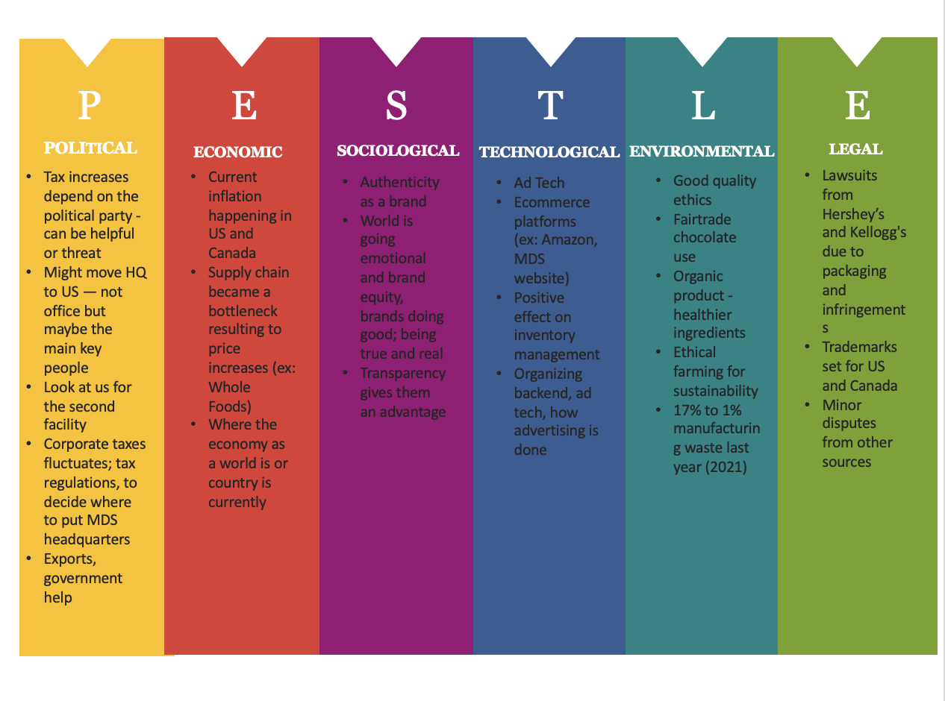

### 

### **Appendix B: Porter’s 5 Forces**

### 

### **Appendix C: SWOT Analysis**

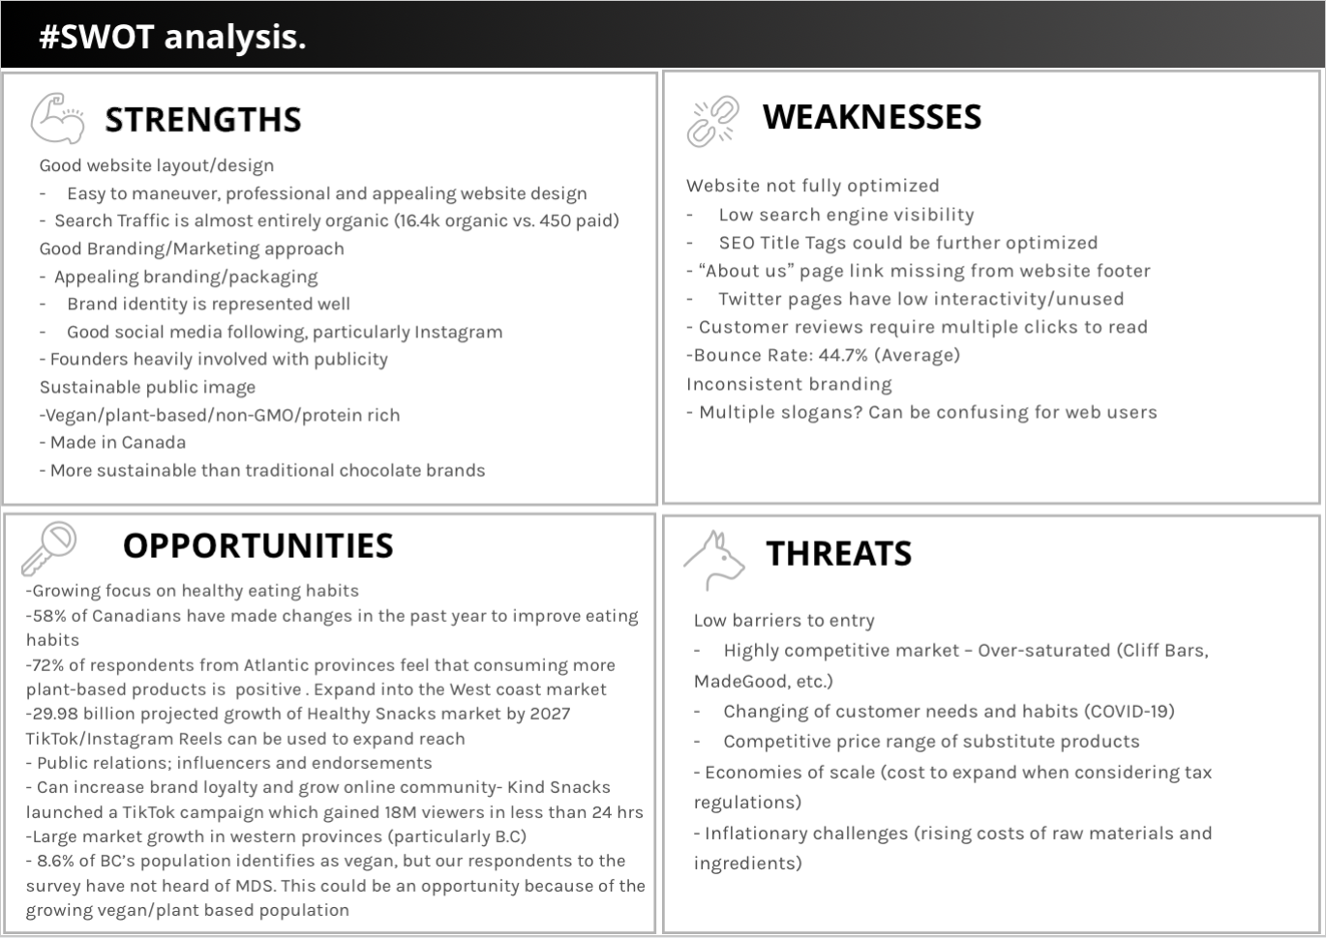

### **Appendix D: Target Market Analysis-Segmentation Variables**

|  |  |
| --- | --- |
| **Segmentation Variable:** | **Data/Information:** |
| **Geographic:** | ***Type:*** Urban/suburban dwellers  ***Focus:*** Geographic regions which are more health conscious (physically active, plant-based diets)  ***Canadian Population***: 38.01 million (Statistics Canada)   * 82% of Canadians live in urban areas * Plant based diets:   + Vegetarians: 2.3 million (Statista)   + Vegans: 850 thousand (Statista) * Ontario Population: 14.57 million (StatsCan)   + Cities: Toronto, Ottawa, Hamilton * British Columbia Population: 5.071 million (Statistics Canada)   + Cities: Vancouver, Greater Vancouver Area, Victoria * Quebec: 8.485 million   + Cities: Montreal, Quebec City, Sherbrooke   ***American Population***: 239.5 million (U.S. Census Bureau)   * 83% of Americans live in urban areas * 19.3% engage in physical activity regularly (Statista) * Plant-based diets:   + Vegetarian: 9.7 million (Gallup)   + Vegan: 1.62 million (Gallup) * Washington D.C population: 692, 683 (U.S. Census Bureau) * Hawaii: 1.46 million (U.S. Census Bureau)   + Cities: Honolulu, East Honolulu * Oregon: 4.22 million   + Portland, Eugene, Salem * California: 39.51 million   + Los Angeles, San Diego, San Jose, San Francisco |
| **Demographic:** | ***Gender***: Female and Male (OECD - 2019)   * Canada: 18.68M males, 18.91m females * America: 161.6M males, 166.7M females   + Mid-Day Squares consumers approx. 80% female   ***Age***: 25-44 (Statista - 2021)   * Canada: 10.51M people   + 5.32M males, 5.19M females * America: 88.14M people (Statista - 2020)   + 44.42M males, 43.72M females   ***Income***:   * Canada: $53,950 CAD (Statistics Canada)   + Age 25-34: $47,000 CAD   + Age 35-44: $60,900 CAD * America: $54,912 USD (Bureau of Labor Statistics)   + Age 25-34: $49,921 USD   + Age 35-44: $59,904 USD   ***Education:***   * Canadians, within the age range, who have a bachelor’s degree, or higher: 8.56M people   + Age 25-34: 64% (3.42M people)     - 73% of women, 56% of men   + Age 30-34: 66% (1.78M people)     - 75% of women, 58% of men   + Age 35-44: 65% (3.36M people)     - 73% of women 57% of males   + NOTE: percentages are from a 2020 study and applied to 2021 population data * Americans, within the age range, who have a bachelor’s degree, or higher: 94M people   + 42% of Americans ages 25 and over have a college degree or higher (U.S. Census Bureau)   + Less conclusive data on age ranges |
| **Psychographic: (Health-conscious consumer)** | ***Social Class:***   * Canada:   + Working and middle-class * America:   + Working, middle, and upper-middle-class   ***Lifestyle***:   * The target consumer leads a “wellness-oriented” lifestyle and is concerned with nutrition, fitness, stress, and the environment. * Frequent gyms, sports complexes, fitness centers and health-food stores * “On the go” lifestyle   ***Personality***:   * Conscientious, productive, ambitious, diligent, friendly, trustworthy, open-minded, educated, skeptical of ‘sensational messaging’ |
| **Behavioral:** | * ***Occasions***: plant-based (vegan, vegetarian) or keto diet * Benefits: satisfy hunger, easy to carry, healthy lifestyle * ***User status***: keep retain regular users and attract targeted nonusers * ***Usage rate***: medium product users * ***Loyalty Status***: somewhat loyal because the users could choose cheaper products |

### **Appendix E: Competitive Analysis**

