## 

## 

## 

## **Ringo Consulting**

BADM 465 Final Report

Real Estate Investment Selection

Consultants: Hannah Evin, Aryan Gupta, Neethu Pramod

## 

## 

## 

## 

## 

## 

## 

## 

## 

## 

## 

## 

## 

## 

## 

## 

## 

## **Capilano University**

## **Table of Contents**

Letter To Client 1

Problem Definition 3

Objectives 3

Stakeholders 3

Situational Analysis 4

Real Estate Alternatives 5-6

Real Estate SMART Analysis 7

Real Estate PCF Analysis 7

Final Recommendation 8

References 9

Appendix A: 10-12

Appendix B: 12-19

Appendix C: 20-21

Appendix D: 21-22

Appendix E: 23-24

## 

# **Letter To Client**

The Ringo Consulting team would like to thank you for being considerate and taking the time to listen to our recommendations regarding which property would be the best to invest in for you.

Our team has picked out five potential properties throughout Tsawassen and Whalley to analyze to find which property would be the most convenient to invest in. Each of the properties that we have studied and researched were areas that we believe can potentially benefit long-term growth in our economy. The properties that Ringo Consulting has chosen to examine were #3601 13618 Whalley, 1792 Starling Dr. Tsawwassen, #204,5055 Spring blvd Tsawwassen, #221,10838 Whalley Blvd, and #3505,13308 Whalley.

Our team has narrowed down each of the prospective properties through various decision-making tools and team collaboration.

Furthermore, the Ringo Consulting team will discuss all of these properties and the tools used in the process. We will also discuss how we came to our final decision concerning which property would be the best to invest in. Here we will go over the data that examines the real estate financials and what it would look like for you when financing our chosen property.

Best Regards,

The Ringo Consulting Team

# **Problem Definition**

Defining the decision problem will thoroughly explain what objectives Ringo consulting has to solve for its client. Ringo consulting will focus on the decision problem in terms of real estate investment decisions that its clients are looking to make. After having an internal review with our team and investors, it was concluded that the decision problem would be:

*"Should our Clients purchase an Investment Property in Tsawwassen*

*or Whalley?"*

**Objectives**

The Ringo Consulting team came up with five objectives to help seek out which property would be the best to invest in. When deciding which property would be the best, we aimed for a property that would help maximize overall cash-flow, while minimizing operating expenses. Our team also opted for a property that would maximize return on investment and minimize any tax implications.

1. Maximize Cash-Flow
2. Minimize Operating Expenses
3. Maximize Return on Investment
4. Maximize Cap Rate
5. Minimize Tax Implications

**Stakeholder Analysis**

**Primary Stakeholders:**

* Investment Partners
* Bank
* Real Estate Agent

**Secondary Stakeholders:**

* Local Community
* Future Tenants/Guests

**Situational Analysis**

While purchasing a property and locations to invest in, we should consider external factors as well. In real estate, the prices of property are rising and the mortgage stress test level increased by the bank. Added to this, economic factors such as rising inflation and an increase in the price of lumper also define the property's worth. Regarding COVID-19, restrictions are still in place, the pandemic and its effects should still be considered. Below are the primary external forces that could both positively and negatively affect the success of Ringo's investment into a property.

* **Rising Real Estate:**
  + Rising real estate prices
  + Increase in mortgage stress test level
* **Economic Factors:**
  + Rising inflation
  + Rising price of Lumper
* **COVID-19:**
  + Restrictions still in place
  + Less relocation and slow rental business

## **Real Estate Alternatives**

**1st Potential Property:**

**#3601,13618 100 Avenue,Whalley**

Price:$799,900

Unit:2 bed 2 bath

Unit size:766 sq ft

Strata fees:$350/m

Rent:$2700/m

Property tax:$2000

Cap Rate:3.28%

Rental terms:No short term rentals according to building bylaws minimum 6 months/1 year lease

**2nd Potential Property:**

**#3505,13308 Central avenue,Whalley**

Price:$899,900

Unit:2 bed 2 bath

Unit size:1289 sq ft

Strata fees:828/m

Rent:$2862/m

Property tax:$3800

Cap Rate:2.34%

Rental terms:No short term rentals according to building bylaws minimum 2 months/1 year lease

**3rd Potential Property:**

**#204,5055 Spring Blvd ,Tsawwassen**

Price:$915,000

Unit:2 bed 2 bath

Unit size:1242 sq ft

Strata fees:484/m

Long term Rent:$2450/m

Airbnb:$135/per night,$4050 per month

Property tax:$3304

Admin expenses for Airbnb(wifi+electricity)=$100/m

Cap Rate:4.46%

Rental terms:Flexible with Airbnb minimum 15 days stay according to building bylaws

**4th Potential property:**

**#221,10838 Whalley Blvd**

Price:$624,900

Unit:2 bed 2 bath

Unit size:933 sq ft

Strata fees:$344

Rent:$2600/m

Property tax:$3217

Cap Rate:3.81%

Rental terms:No short term rentals according to building bylaws minimum 6 months/1 year lease

**5th potential property:**

**#107,1792 starling drive ,Tsawwassen**

Price:$649,900

Unit:2 bed 2 bath+den

Unit size:1067 sq ft

Strata fees:$280

Long term rent:$2380/m

Airbnb:$130 per night /$3900 per month

Admin expenses for Airbnb(wifi+electricity)=$100/m

Property tax:$1800

Cap rate:6.22%

Rental terms:Short term rentals and airbnb permitted according to building bylaws

**Real Estate SMART Analysis**

After searching and analyzing each prospective investment property, our team conducted a SMART analysis to examine each property further. The SMART tool helped us weigh out and assess the criteria of each property. This tool was beneficial when configuring how vital each component was. The SMART tool helped our team consider which alternative would be the best choice for the final decision.

These are shown in the appendix, together with the Cap rate of each proposal. (note that 0 is the score for the worst property on a given attribute and 100 a score for the best property on that attribute).

We then considered a hypothetical property that had the worst performance on all the non-monetary attributes.We then considered which criteria would most likely make this real estate proposal. We concluded that Airbnb restriction would be the most desirable and amenities would be the worst. Nearby facilities,crime rate and building amenities were respectively considered to be 50%,30%,20% as important as the airbnb restriction.

**Real Estate PCF Analysis**

After analyzing each property through using the SMART tool, we then used the Pro Cons Fix tool. Here our team compared two of the designated areas, which were Tsawassen and Whalley. This tool helped our team understand the pros and cons of each city. Using this tool helped us come to a final decision much faster, and improved our overall understanding of the situation.

**Final Recommendation**

Our team concluded that investing in 107 1792 Starling Drive Delta, BC, V4M 0E4 Tsawwassen North would be the best option based on the given data and information. After assessing this property, our team found that it would offer the most benefits. As Tsawassen is an emerging city, it provides many opportunities regarding Airbnb as there are not many options for hotels. Investing in property for Airbnb would also bring in a positive cash flow.

We also found that it offers many opportunities for amenities. There is shopping, recreation, as well as a ferry terminal that brings in many tourists. This property would also be a good investment as it will appreciate over time as the overall community has undergone significant residential developments. If you have any more follow-up questions, our team would be happy to help. Please contact our team at any time, and we look forward to working with you regarding this real estate investment opportunity.

## **References**

119-1792 Starling Drive, Delta, BC, Apt/Condo For Sale. (n.d.). Retrieved from <https://www.rew.ca/properties/3364817/119-1792-starling-drive-delta-bc>

204-5055 Springs Boulevard, Delta, BC, Apt/Condo For Sale. (n.d.). Retrieved from [https://www.rew.ca/properties/3270621/204-5055-springs-boulevard-delta-bc?search_params[query]=#204,5055](https://www.rew.ca/properties/3270621/204-5055-springs-boulevard-delta-bc?search_params%5Bquery%5D=#204,5055) Spring blvd Tsawwassen

221-10838 Whalley Boulevard, Surrey, BC, Apt/Condo For Sale. (n.d.). Retrieved from <https://www.rew.ca/properties/3394737/221-10838-whalley-boulevard-surrey-bc>

3505-13308 Central Avenue, Surrey, BC, Apt/Condo For Sale. (n.d.). Retrieved from <https://www.rew.ca/properties/3324093/3505-13308-central-avenue-surrey-bc>

3601-13618 100 Avenue, Surrey, BC, Apt/Condo For Sale. (n.d.). Retrieved from [https://www.rew.ca/properties/3343232/3601-13618-100-avenue-surrey-bc?search_params[query]=3601](https://www.rew.ca/properties/3343232/3601-13618-100-avenue-surrey-bc?search_params%5Bquery%5D=3601) 13618 100 Avenue

**Appendix A: PCF Analysis**

## REQUIREMENTS

Budget-$600,000 + 3% line of credit on $400,000

Area-Whalley and Tsawwassen

**City:Tsawwassen**

| **Decision Problem** | Should I purchase a 2 bedroom 2 bath unit as an investment property in Tsawwassen? |
| --- | --- |
| **Stakeholders & Bias** | Private lender/bank,Realtor,Investor |
| **Alternative Considered** | Purchase a property in Whalley |

PROS

| **P1.** | Amenities and proximity eg close to Shopping ,ferry and beach |
| --- | --- |
| **P2.** | Safe and family oriented communities |
| **P3.** | Emerging market for airbnb due to lack of hotels in the city |
| **P4.**  **P5** | Still an emerging city so huge opportunity for appreciation  Lots of tourist visits due to the ferry terminal |

CONS

| ~~C1.~~ | Far from other metro Vancouver cities |
| --- | --- |
| **C2.** | Highway noise |
| C3. | Located on a native leasehold land which creates issues with securing financing |
| C4. | No restaurants open over night |

FIXES

| *F1* | *No fix* |
| --- | --- |
| *F2.* | *Buy a unit in a newer building which has soundproof windows* |
| *F3.* | *Use private lender to finance the property ,the interest rate may be little higher than usual but worth the appreciation* |
| *F4.* | *No fix* |

| **Decision & Next Steps** | Tsawwassen is an emerging city and has lots of tourist attractions like Tsawwassen mills,big splash water park ,beaches and it is close to the ferry.There is a huge opportunity for appreciation as the condominium market is Tsawwassen is still being developed so private lender can be considered for financing and purchasing the property.Leasing property on airbnb would have the opportunity of positive cash flow than long term rentals and property would be well maintained with airbnb as it would be cleaned regularly. |
| --- | --- |

**City:Whalley**

| **Decision Problem** | Do I Purchase an Investment Property in Whalley, Surrey? |
| --- | --- |
| **Stakeholders & Bias** | Bank, The Client, Realtor, Investors , the property owner, local community  Bias or key concern- Whalley is an emerging city which would be a good investment, however, a key concern would be that it is a high-crime area |
| **Alternative Considered** | **Purchase Property In Tsawwassen** |

PROS

| **P1.** | Lots of surrounding amenities, recreation facilities, parks, and sky train stations |
| --- | --- |
| **P2.** | Emerging city, lots of new developments, high rises etc |
| **P3.** | One of the populated cities in BC, second largest city in BC |
| **P4.**  **P5.**  **P6.** | Improving neighborhood  It is historic, One of surrey's oldest neighborhoods  Good middle ground between a small town and Downtown vancouver |

CONS

| C1 | Crime rates are high, lots of drugs, violence, and theft |
| --- | --- |
| **C2.**  C3.  C4.  C5. | Considered one of the more dangerous parts of surrey and has a bad reputation  Noisy due to the sky train, ambulances, and crime  Can be unsafe to walk around at night  Not a very family oriented area in Surrey |
|  |  |
|  |  |

FIXES

| *F1&F2* | *Consider buying property that has 24/7 surveillance, security systems,* |
| --- | --- |
|  |  |
| *F3.* | *Buy property in a high-rise that is also more sound proof* |
| *F4.*  *F5* | *Don’t walk around at night, avoid alleys, buddy system, walk in public areas*  *Consider buying property in a more family oriented area* |

| **Decision & Next Steps** | Whalley has become quite the emerging city in recent years, and has lots of potential. It offers many different amenities such as recreation facilities, parks, and sky train stations. Whalley is developing as there are many projects and developments that are underway. It would be a great opportunity to finance and purchase property in Whalley. |
| --- | --- |

|  |  |  |  |  |  |  |
| --- | --- | --- | --- | --- | --- | --- |

**Appendix B: Real Estate Flyers**

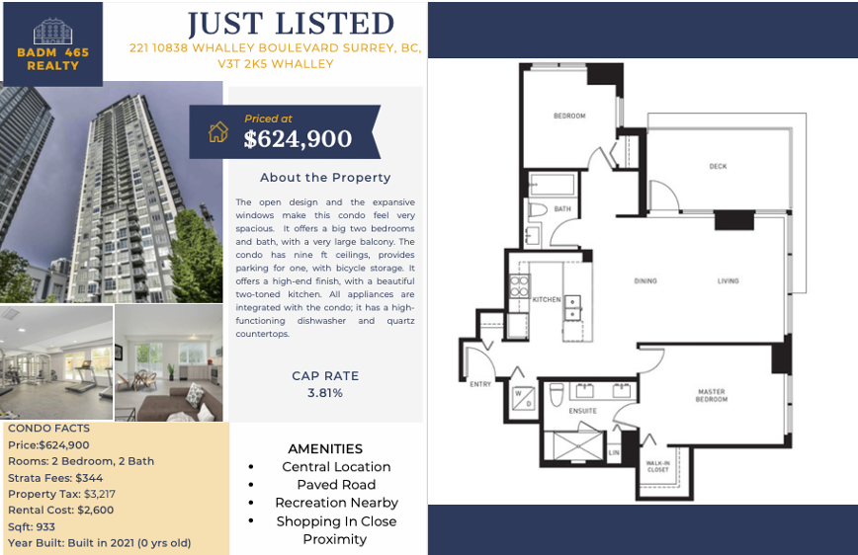

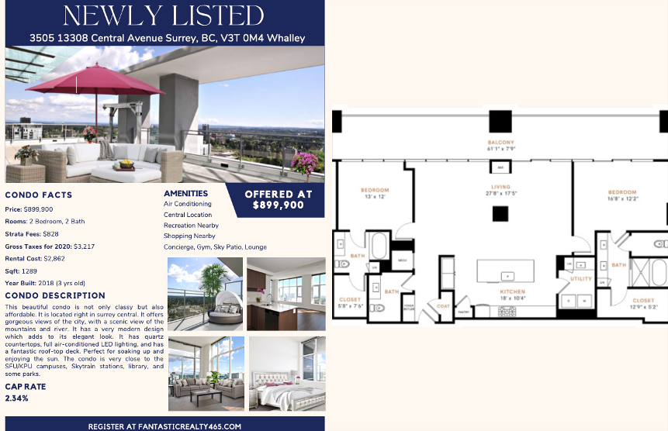

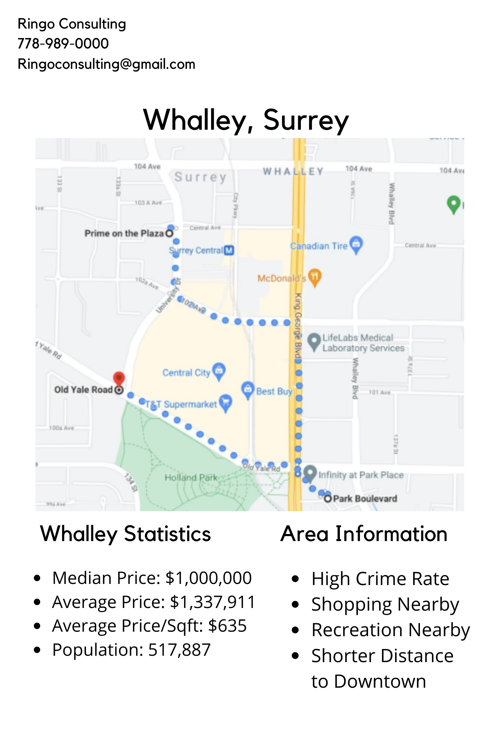

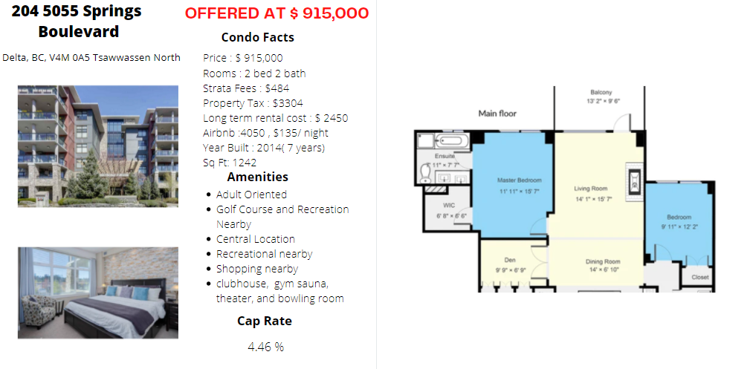

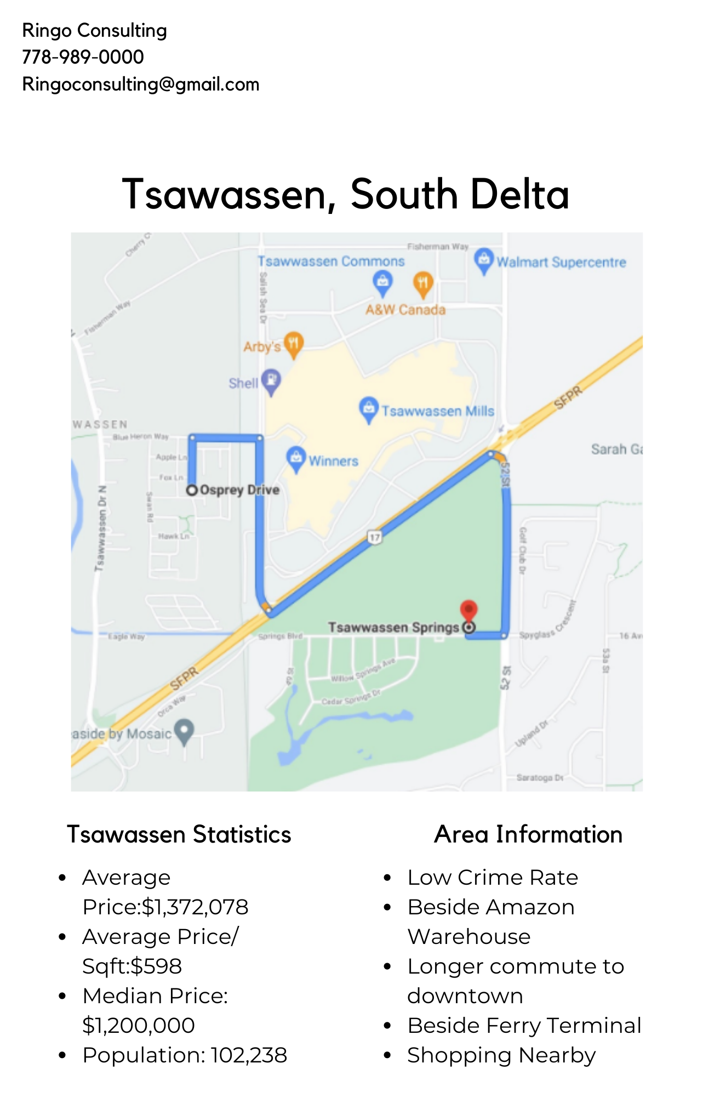

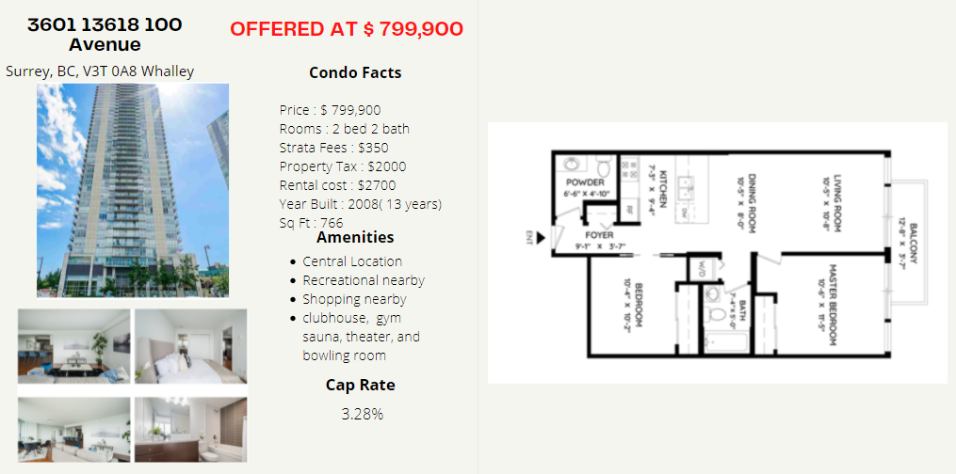

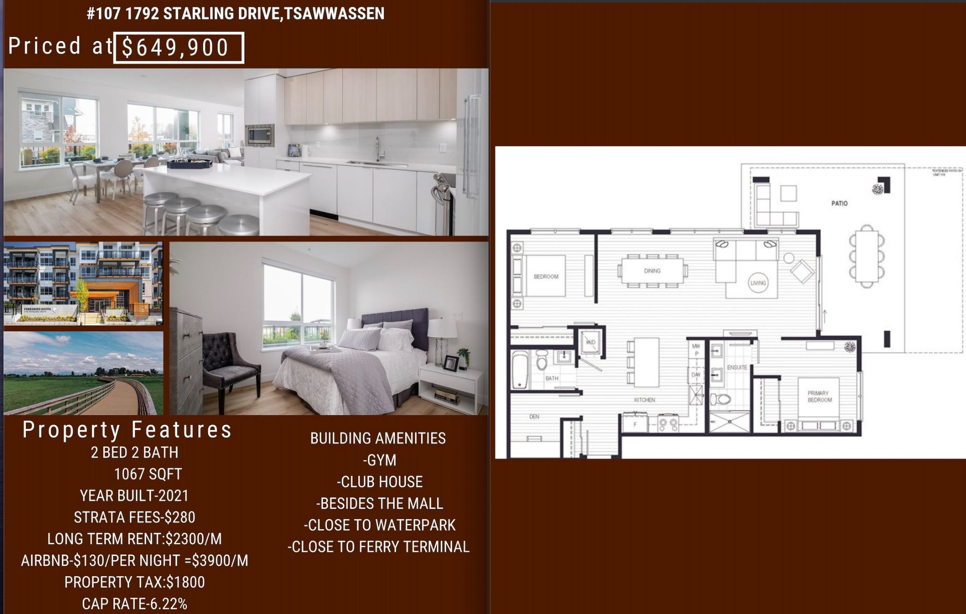

**Appendix C: Calculations**

Calculations-

Cap Rate= NOI/Purchase price *100

NOI=(Rent*12)-(Strata*12)-Property Tax

For example -

1792 Starling drive-

Airbnb per night =$130

For Airbnb-Wifi+Electricity expenses =100/m =$1200 annually

NOI with Airbnb=(3900*12)-(280*12)-1800-(1200)

=$40440

Cap Rate=40440/649,900*100

Cap Rate=6.22%

Calculations-

Cap Rate

221 10838 Whalley Boulevard Surrey, BC, V3T 2K5 Whalley

NOI (2600*12)- (344*12) -3217=31200

31,200-4128-3217=23855

Cap Rate= 23855/624,900*100= 3.81%

# 204 5055 Springs Boulevard

Delta, BC, V4M 0A5, Tsawwassen North

Airbnb per night=$135 and wifi+electricity=$100/m

NOI with Airbnb=(4050*12)-(484*12)-2000 = $40792

Cap Rate = 40792/915000*100 =4.46%

3601 13618 100 Avenue

Surrey, BC, V3T 0A8, Whalley

NOI =(2700*12)-(350*12)-2000 = 26200

Cap Rate = 26200/799900*100 = 3.28%

#3505,13308 Whalley

NOI=3100*12-(828*12)-2800 =$21091

Cap Rate=24454/899,900*100

Cap Rate =2.71%

**Appendix D: SMART Analysis**

|  | **Airbnb restriction** | **Crime Rate** | **Nearby Facilities** | **Building Amenities** |  |  |
| --- | --- | --- | --- | --- | --- | --- |
| Normalized Weight | 50% | 15% | 25% | 10% |  |  |
| Raw Weight | 100 | 30 | 50 | 20 | 200 |  |
| **Site** | **Airbnb restriction** | **Crime Rate** | **Nearby Facilities** | **Building Amenities** | **Cap Rate** | **ABP** |
| #3601 13618  Whalley | 20 | 10 | 100 | 100 | 3.28% | 46.5 |
| 1792 Starling Dr,  Tsawwassen | 100 | 100 | 40 | 90 | 6.22% | 84 |
| #204,5055 Spring blvd  Tsawwassen | 90 | 90 | 0 | 70 | 4.46% | 65.5 |
| #221,10838  Whalley Blvd | 10 | 0 | 60 | 80 | 3.81% | 28 |
| #3505,13308  Whalley | 0 | 10 | 80 | 0 | 2.71% | 21.5 |
|  |  |  |  |  |  |  |

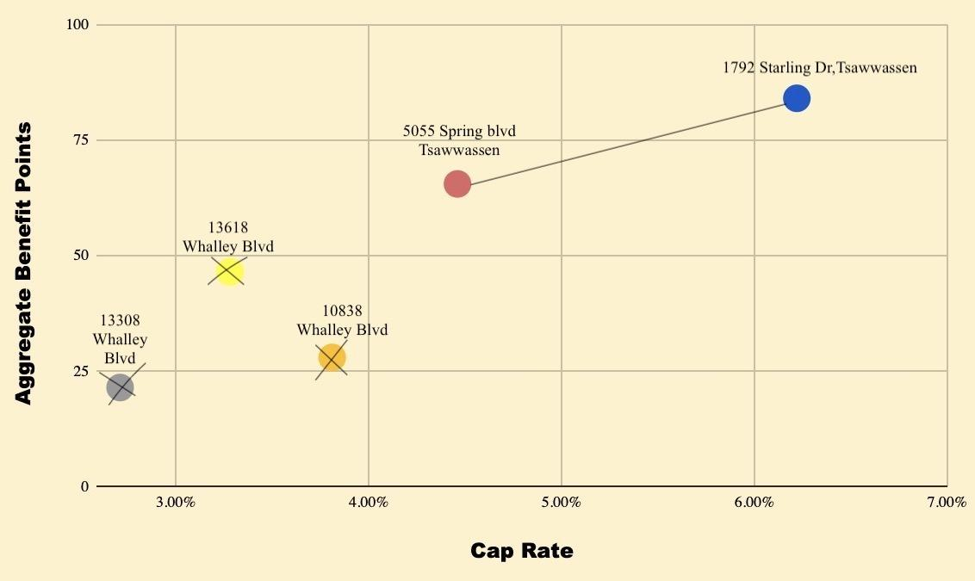

ABP= sum total of weighted criteria

ABP Calculations

#3601 13618 Whalley

20*50% + 10*15% + 100*25% + 100*10% = 46.5%

1792 Starling Dr, Tsawwassen

100*50% + 100*15% + 40*24% + 90*10%

50+ 15 + 9.6 + 9 = 83.6

#204,5055 Spring blvd,Tsawwassen

90*50% + 90*15% + 0*25% + 70*10%

45 + 13.5 + 0 + 7 = 65.5

#221,10838, Whalley Blvd

10*50% + 0*15% + 60*25% + 80*10%

5 + 0 + 15 + 8 = 28

#3505,13308, Whalley

0*100% + 10*15% + 80*25% + 0*10%

0 + 1.5 + 20 + 0 = 21.5

**Appendix E: Financials**

Appreciation rate for Tswassen -5.5% as personally seen with real estate trend

RoI calculations =Total yearly income /Cash put down

Tax-50% capital gain and 30% business income

Earnings after tax =50% of 77494.97 and 30% 110,332

